Charles Hesketh

Test 1

**Problem 1:**

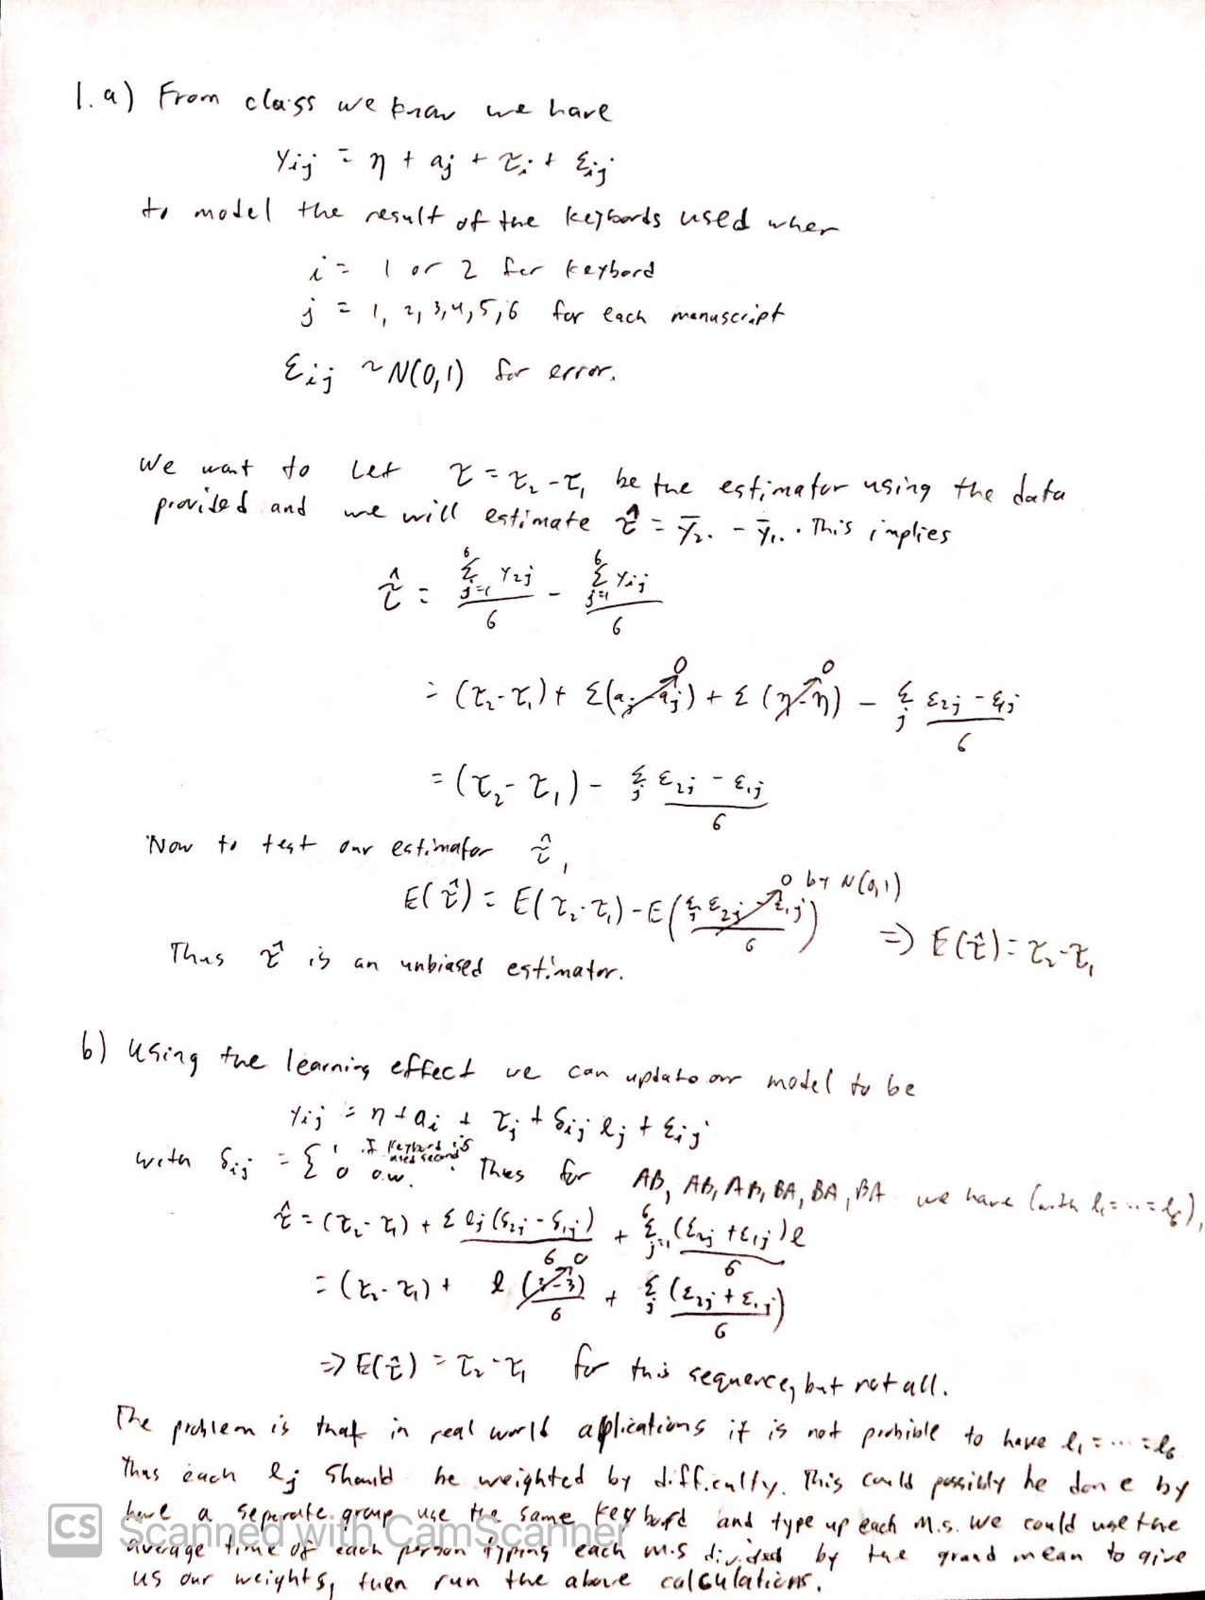

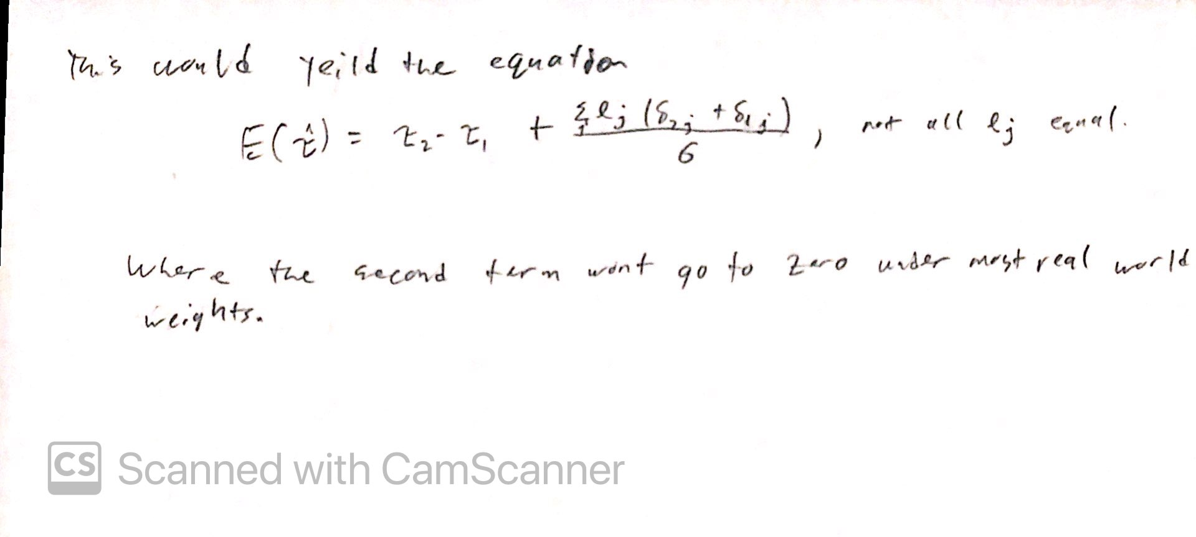

**Problem 2:**

1. For Bonferroni our confidence intervals are:  
   AB: (-0.8002,0.4401)

AC: (-0.2402,1.0001)

AD: (-0.1802,1.0601)

BC: (-0.0602,1.1802)

BD: (-0.0002,1.2402)

CD: (-0.5602,0.6802)

For Tukey our confidence intervals are:  
AB: (-0.7698,0.4098)

AC: (-0.2098,0.9698)

AD: (-0.1498,1.0298)

BC: (-0.0298,1.1498)

BD: (-0.0302,1.2098)

CD: (-0.5298,0.6498)

Tukey has a shorter interval then Bonferroni for the confidence interval of 95% given the data.

**Problem 3:**

1. This experiment is designed as a one way layout with:

Factors=1

Levels=4

Sample Size=30

1. The p-value for this experiment, with probability of 8.98 and degrees of freedom of 3 and 26, is 0.00059, suggesting that there is a statistical difference in at least one of the treatments.
2. Using the Tukey method we get the following comparisons:

AB=0.437

AC=4.454

AD=2.616

BC=4.153

BD=2.276

CD=1.497

1. Using the contrast provided we obtain a p-value of 0.0188 which is above the 0.01 level we were testing, thus the data does not support a statistical difference between the brand name drugs and the generic drugs.

**Problem 4:**

I first restructure the data so that we had a variable column and a value column. This allowed us to create a linear model to then calculate metrics. From here we used Bonferroni and Tukey’s method to calculate the confidence intervals. This resulted in maximum confidence intervals of:

AB=(0.8585,2.4675)

AC=(-0.5205,1.0885)

BC=(-2.1835,-0.5745)

With a p value of 1.107e-14. Therefor, the data suggest there is a significant difference between the weights of the 3 machines.

Appendix: Code

library(reshape2)

setwd("C:\\Users\\User\\Desktop\\School\\Math_531T\\Exam1")

#####################################################

#1)

#####################################################

#2)

data<-read.table("http://www2.isye.gatech.edu/%7Ejeffwu/book/data/pulp.dat", h=T)

Y = as.matrix(data)

n = rep(nrow(Y),ncol(Y))

k=ncol(Y)

N=sum(n)

alpha = 0.05

Yidot = apply(Y, 2, mean) # sample mean for each treatment

avgY = mean(Yidot) # grand mean

kprime <- choose(k,2)

kprime = choose(k,2)

res = sum((Y-t(Yidot%*%t(rep(1,5))))^2)/(N-k)

b=qt(1-(alpha/(2*kprime)), N-k)*sqrt(2/5*res)

t=qtukey(1-alpha,k,N-k)/sqrt(2)*sqrt(2/5*res)

stats=matrix(0,ncol(Y)-1,ncol(Y))

for(j in 1:ncol(Y)-1)

{

for(i in j:ncol(Y))

{

stats[j,i]=Yidot[i]-Yidot[j]

}

}

uppBoundB=stats

uppBoundB[1,2:4]=stats[1,2:4]+b

uppBoundB[2,3:4]=stats[2,3:4]+b

uppBoundB[3,4]=stats[3,4]+b

lowBoundB=stats

lowBoundB[1,2:4]=stats[1,2:4]-b

lowBoundB[2,3:4]=stats[2,3:4]-b

lowBoundB[3,4]=stats[3,4]-b

uppBoundT=stats

uppBoundT[1,2:4]=stats[1,2:4]+t

uppBoundT[2,3:4]=stats[2,3:4]+t

uppBoundT[3,4]=stats[3,4]+t

lowBoundT=stats

lowBoundT[1,2:4]=stats[1,2:4]-t

lowBoundT[2,3:4]=stats[2,3:4]-t

lowBoundT[3,4]=stats[3,4]-t

#####################################################

#3)

#b)

f=21.47/2.39

pf(f,3,26,lower=F)*2

#c)

yA=66.1

yB=65.75

yC=62.63

yD=63.85

k=4

Nk=26

alpha = 0.01

a=1/7

b=1/8

c=1/9

d=1/6

AB=abs(yA-yB)/(sqrt(2.39*(a+b)))

AC=abs(yA-yC)/(sqrt(2.39*(a+c)))

AD=abs(yA-yD)/(sqrt(2.39*(a+d)))

BC=abs(yB-yC)/(sqrt(2.39*(b+c)))

BD=abs(yB-yD)/(sqrt(2.39*(b+d)))

CD=abs(yC-yD)/(sqrt(2.39*(c+d)))

qtukey(1-alpha,k,Nk)/sqrt(2)

AB

AC

AD

BC

BD

CD

#D)

con=1/2*(yA+yB)-1/2*(yC+yD)

con2=c(1/2,1/2,-1/2,-1/2)

contrasts(as.factor(con2),as.factor(c(1,0,-1,0)))

AB=abs(yA-yB)/(sqrt(2.39*(a+b)))

AC=abs(yA-yC)/(sqrt(2.39*(a+c)))

AD=abs(yA-yD)/(sqrt(2.39*(a+d)))

BC=abs(yB-yC)/(sqrt(2.39*(b+c)))

BD=abs(yB-yD)/(sqrt(2.39*(b+d)))

CD=abs(yC-yD)/(sqrt(2.39*(c+d)))

SE=sqrt(2.39*(1/4*a+1/4*b+1/4*c+1/4*d))

f=(1/2*yA+1/2*yB-1/2*yC-1/2*yD)/SE

pf(f,3,26,lower=F)*2

#####################################################

#4)

data=read.csv("cement.csv")

head(data)

data.m = melt(data)

g=lm(value~variable, data = data.m)

anova(g)

Y = as.matrix(data)

n = rep(nrow(Y),ncol(Y))

k=ncol(Y)

N=sum(n)

alpha = 0.05

Yidot = apply(Y, 2, mean) # sample mean for each treatment

avgY = mean(Yidot) # grand mean

kprime <- choose(k,2)

kprime = choose(k,2)

res = sum((Y-t(Yidot%*%t(rep(1,nrow(Y)))))^2)/(N-k)

b=qt(1-(alpha/(2*kprime)), N-k)*sqrt(2/5*res)

t=qtukey(1-alpha,k,N-k)/sqrt(2)*sqrt(2/5*res)

stats=matrix(0,ncol(Y)-1,ncol(Y))

for(j in 1:ncol(Y)-1)

{

for(i in j:ncol(Y))

{

stats[j,i]=Yidot[i]-Yidot[j]

}

}

uppBoundB=stats

uppBoundB[1,2:3]=stats[1,2:3]+b

uppBoundB[2,3]=stats[2,3]+b

lowBoundB=stats

lowBoundB[1,2:3]=stats[1,2:3]-b

lowBoundB[2,3]=stats[2,3]-b

uppBoundT=stats

uppBoundT[1,2:3]=stats[1,2:3]+t

uppBoundT[2,3]=stats[2,3]+t

lowBoundT=stats

lowBoundT[1,2:3]=stats[1,2:3]-t

lowBoundT[2,3]=stats[2,3]-t